- Start ModelMuse, select “Create a new MODFLOW model”, and click “Next”.
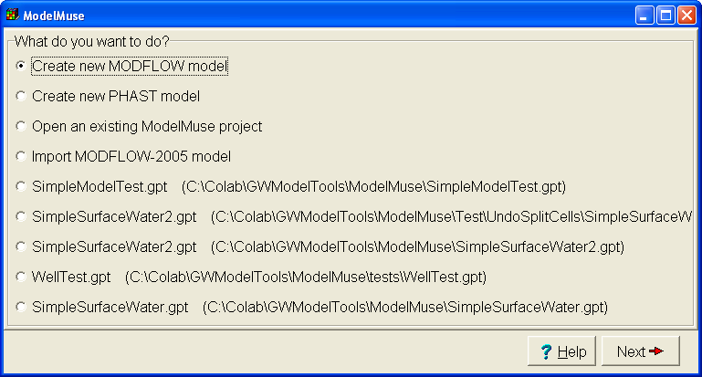
- Change the number of layers to 1, change the name of the layer group to “Aquifer” and click “No grid”
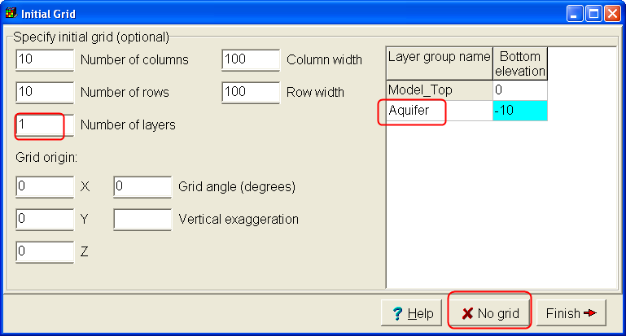
- Select File|Import Image…
- Click “Select Image” and select “Watershed.emf”
- The image contains four cross marks with coordinates. Click on each of the cross marks and enter the coordinates. (This is so the image can be displayed at the correct location.) Then click OK.
- You should now see the image in the top view of the model. If necessary, zoom out so you can see the entire outline of the watershed.
- Click the “Create polygon object” button and trace the outline of the watershed. Double-click on the last vertex to finish the polygon.
- Check the “Use to set grid cell size” button and set the “Grid cell size” to 1000. Then click OK.
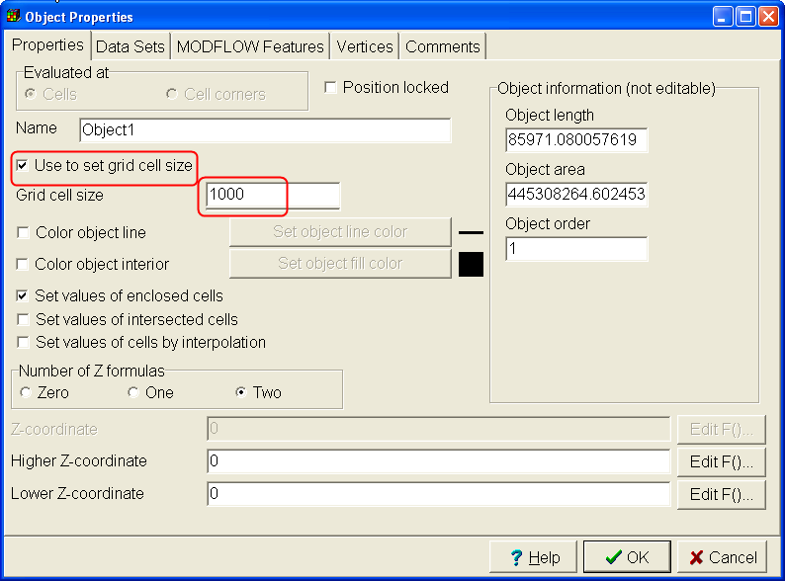
- Click the “Generate grid” button and then click OK. The grid should have been created.
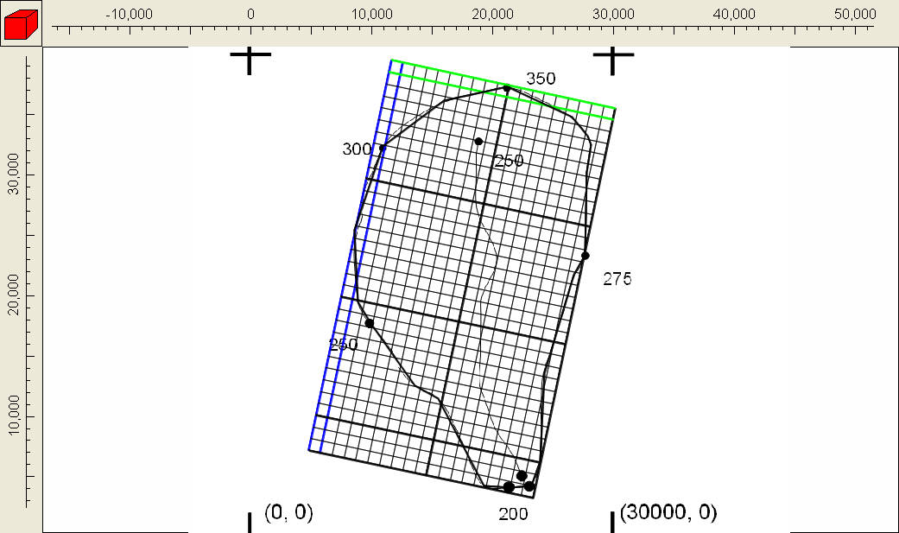
- The image of the watershed has several dots around the outside of the watershed that indicate the elevation of the watershed boundary at those locations. There is also a line representing a stream with dots at either end indicating the elevation of the stream at either end. We will use those locations to define the elevation of the top of the model.
- Click on the “Create point object” button and click on the dot near the north of the model labeled “350”.
- In the Object Properties dialog box, uncheck “Set values of intersected cells” and check “Set values of cells by interpolation”. Change the number of Z formulas to Zero.
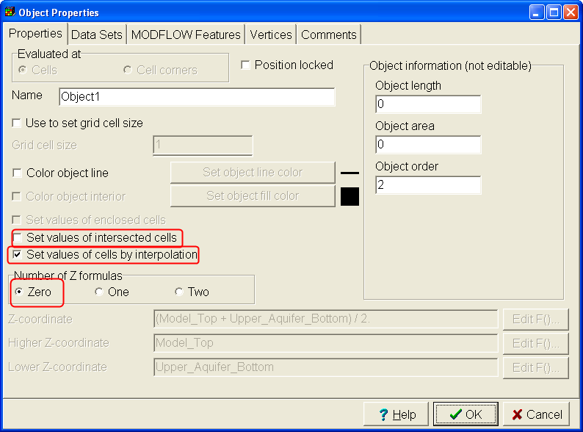
- On the “Data Sets” tab, expand “Required|Layer Definition” and check the check box for Model_Top. Enter “350” as the formula for Model_Top. Click OK. (You will get a warning message.)
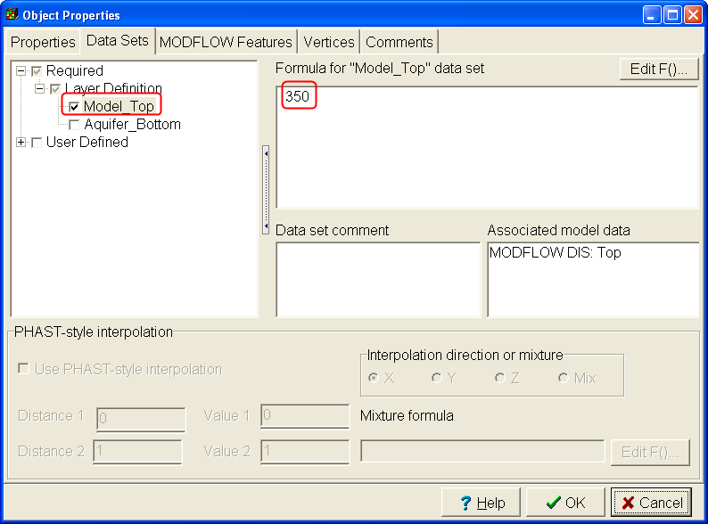
- You will get a warning message “You are attempting to specify the value of a data set by interpolation but at least one of the data sets, Model_Top, does not have an interpolator assigned. Is this really what you want?” Click “Yes”.
- Select Data|Edit Data Sets. Expand “Required|Layer Definition” and select “Model_Top” Set “Interpolation” to “Fitted Surface. You can find out about interpolation in ModelMuse in the ModelMuse help.
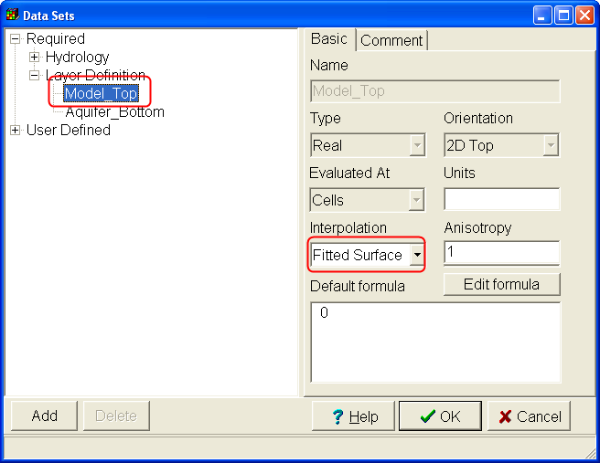
- Create point objects for the other points along the edge of the watershed. Use them to assign elevations of the top of the model. Once you have created at least three objects, you may notice the elevations of the top of the model changing on the front and side views of the model. Be sure to check “Set value of cells by interpolation” for all of them.
- It is worthwhile to color the grid using the “Model_Top” data set just to see what it looks like at this point. Select “Data|Data Visualization” and select “Color Grid” on the left. Set the data set to “Data Sets|Required|Layer Definition|Model_Top” and click Apply.
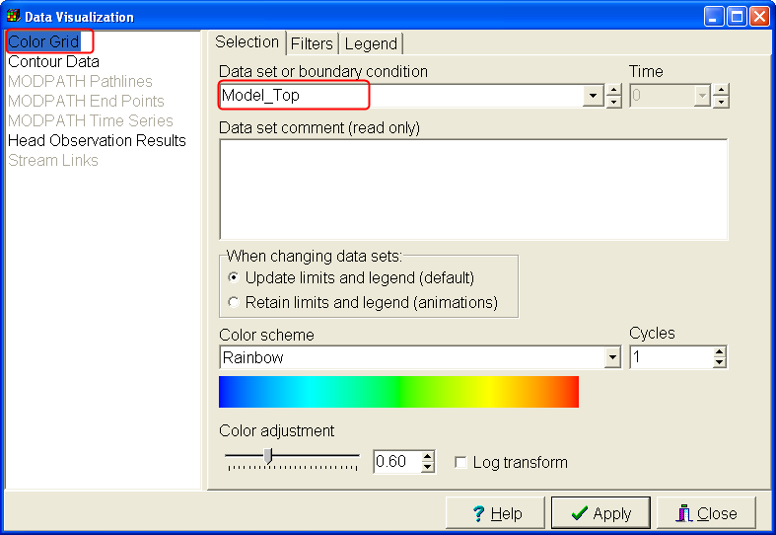
- The grid should look something like this.
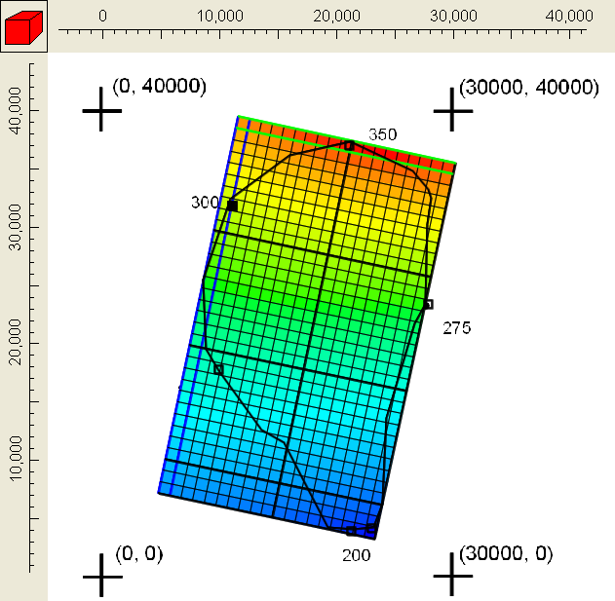
- Turn off coloring the grid so you can see the image through the grid.
- Next we will trace the river and assign the top of the model along the river.
- Click the “Create polyline object” button and click along the length of the river. Double-click to finish the river and display the Object Properties dialog box. In the Object Properties dialog box, uncheck “Set values of intersected cells” and check “Set values of cells by interpolation”. Change the number of Z formulas to Zero. Don’t do anything on the Data Sets tab yet. Instead, just click OK.
- Click the Edit vertex values button and double-click on the vertex at the north end of the river.
- Enter “Elevation” as the key and “250” as the value.
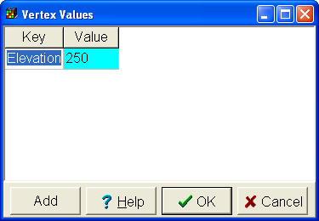
- Repeat at the southern end of the object except specify 200 as the value.
- Click the “Select” button and then double-click on the river to display the Object Properties dialog box again.
- Go to the Data Sets tab and check the check box for the Model_Top data set. Then click the “Edit F() button to display the Formula Editor.
- In the Formula Editor, expand “Functions|Object” and double-click on “InterpolatedVertexValue”. Then replace “Key” with “Elevation”. “Elevation” should be in double quotes.
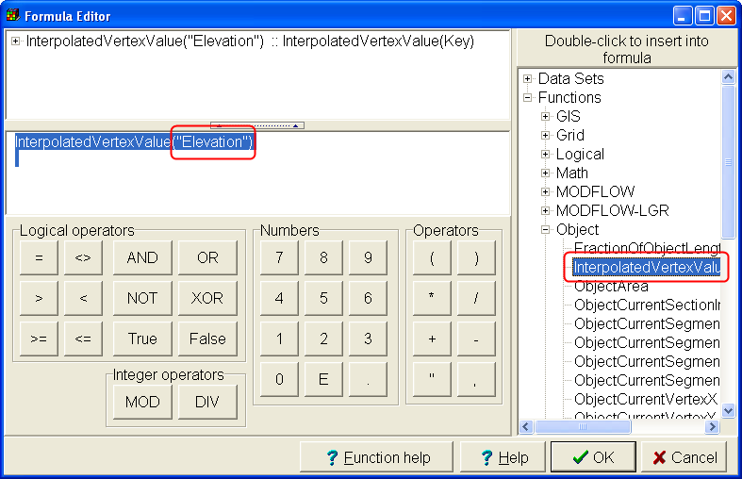
- Click on the Function Help button to read about what the InterpolatedVertexValue function does. (It interpolates along the length of an object.)
- Color the grid again with the Model_Top data set. You should get something similar to this. Try moving any of the objects define the top of the model and see what happens. Click the undo button to reverse your changes.
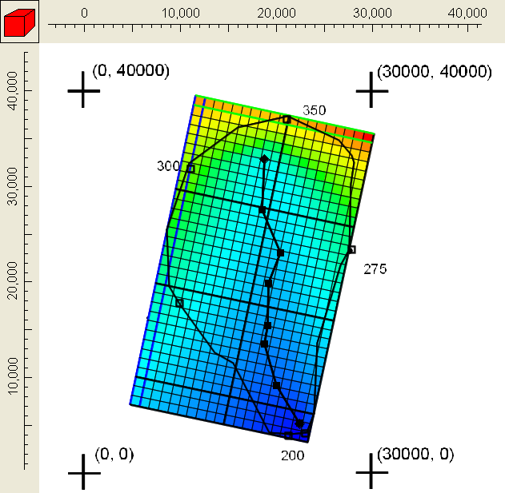
- The thickness of the aquifer ranges from 100 at the edge of the watershed to 150 near the center of the watershed. A contour map of the thickness is shown below.
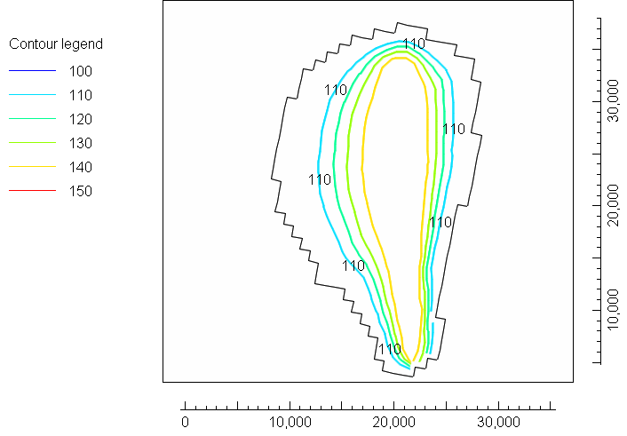
- We will import a Shapefile to define the aquifer thickness. Select “File|Import|Shapefile…” and select Thickness.shp. Check “Set values of cells by interpolation”.
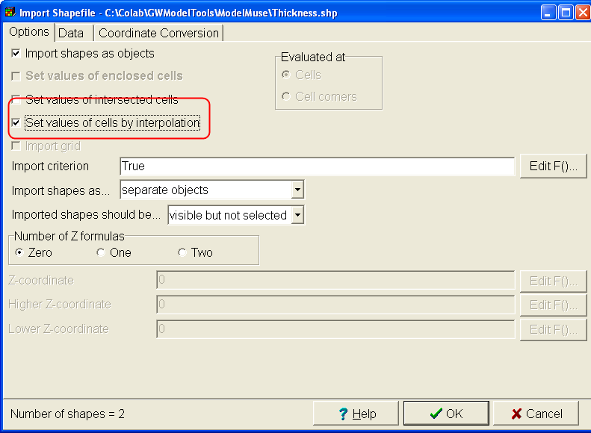
- Go to the Data tab and check the checkbox for the THICKNESS attribute and change the interpolation to Inv. Dist. Sq. Then click OK.
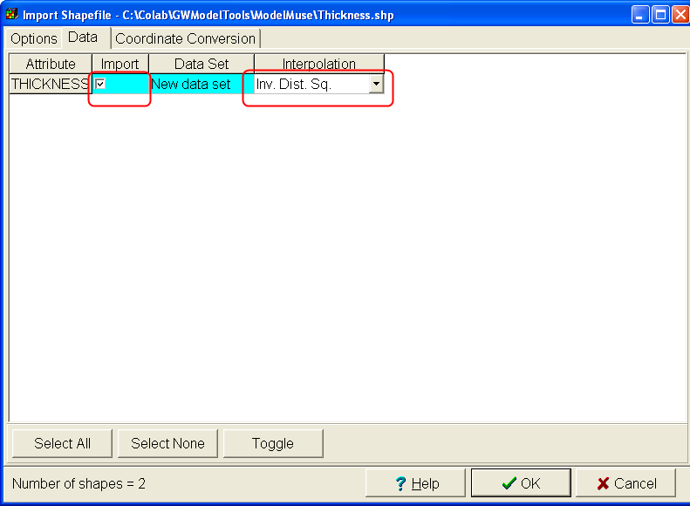
- Select “Data|Edit Data Sets” and select the Aquifer_Bottom data set. Change its default formula to “Model_Top - THICKNESS”.
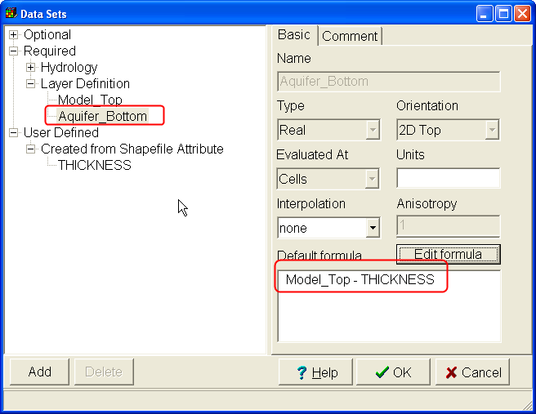
- We want the aquifer to have 3 layers. We will subdivide the existing layer to do that. Select “Model|MODFLOW Layer Groups” and go to the Discretization tab. Change the Vertical discretization to 3 and click OK. (You could have added additional layer groups if you wanted to vary the thickness of the layers independently from one another.)
- Now we have finished defining the geometry. Next we define the cells that are active in the model, the initial head, and the hydraulic conductivity. Select Data|Edit Data Sets, expand Required|Hydrology and select the “Kx” data set. Set its formula to “0.0001”. Select the MODFLOW_Initial_Head data set and set its formula to 400. Select the “Active” data set and set its formula to “False”. (By default all the cells in the model are active. This will make all cells inactive”.) Click OK.
- Next click the “Create polygon object” button and draw a polygon around the edge of the watershed. In the Object Properties dialog box, make sure that the number of Z-formulas is set to two and set the Higher-Z coordinate and Lower-Z coordinate formulas are set to “Model_Top” and “Aquifer_Bottom” respectively. On the Data Sets tab, expand “Required|Hydrology” and check the check box for the Active Data set and set its formula to “True”. Click OK.
- To check whether the active cells have been set properly, select “View|Show or Hide 2D Grid|Show active”. Your model should look similar to this. Note that the gridlines are displayed only in the active part of the model.
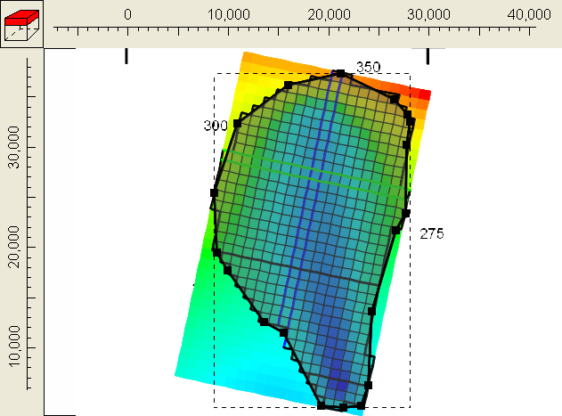
- Next check the stress periods for the model. Select “Model|MODFLOW Time” to display the MODFLOW Time dialog box. There is one steady-state stress period defined. It starts at time = -1 and ends at time = 0. (If you add a transient stress period, it will start at time = 0 – a convenient number.) Click Cancel to close the dialog box.
- Next we want to define the recharge rate. We will assume that recharge is uniform over the entire model and has a rate of 2E-9 m/s. First we need to activate the Recharge package. Select “Model|MODFLOW Programs and Packages. Expand “Boundary conditions|Specified flux” and check the check box for the Recharge package. Click OK.
- Next draw a polygon surrounding the model. It doesn’t matter whether or not inactive cells are enclosed by the polygon but all the active cells should be enclosed by it.
- In the Object Properties dialog box, set the number of Z-Formulas to one and set the formula for the Z-coordinate to Model_Top. On the MODFLOW Features tab, check the checkbox for the Recharge package, set the starting time to -1, the ending time to 0 and the recharge rate to 2E-9. Click OK.
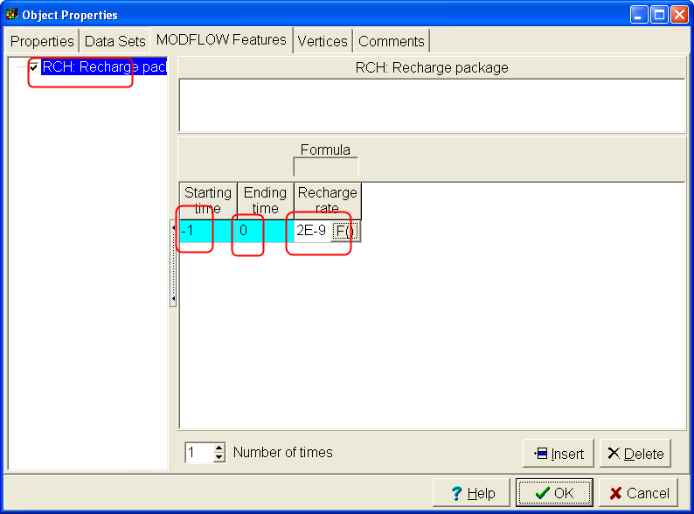
- The northern half of the river is intermittent so it is more convenient to simulate it with the drain package that the river package. We will simulate the southern half the river with the river package. Select “Model|MODFLOW Programs and Packages. Expand “Boundary conditions|Head-dependent flux” and check the check boxes for the River and Drain packages. Click OK.
- Create two polyline objects to define the northern and southern halves of the river as illustrated below. (The part simulated with the Drain package is blue. The orange part is simulated with the River packages.) For both objects, in the Object Properties dialog box, the number of Z-Formulas should be One and the formula for the Z-Coordinate should bye “Model_Top”. This ensures that the drain and river boundaries are only in the top layer instead of in all three layers.
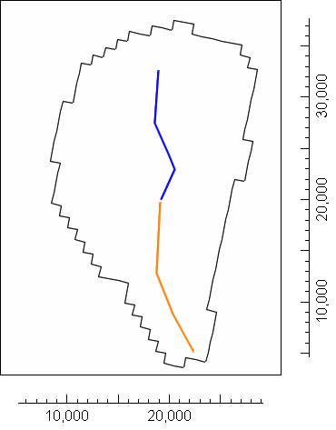
- For the object defining the northern part of the river, switch to the MODFLOW Features tab and check the checkbox for the Drain package, Set the starting and ending times to -1 and 0 respectively, Set the formula for the Elevation to Model_Top and set the conductance per unit length to 0.001. Click OK.
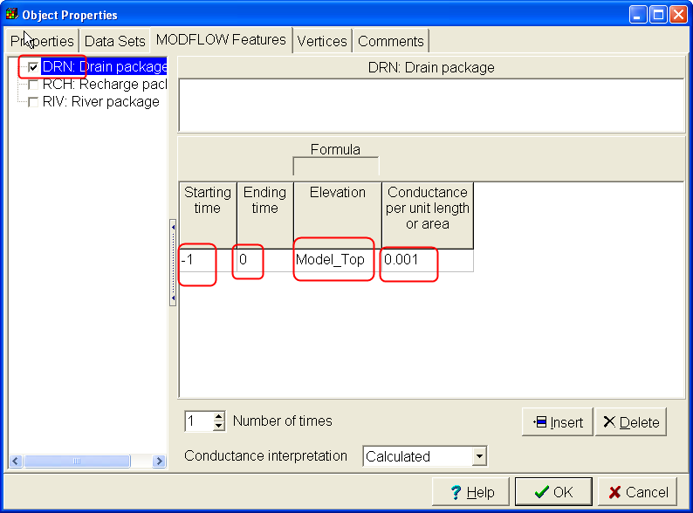
- For the object defining the southern part of the river, switch to the MODFLOW Features tab and check the checkbox for the River package, Set the starting and ending times to -1 and 0 respectively, Set the formula for the River stage to Model_Top .Set the conductance per unit length to 0.001. Set the River bottom to Model_Top - 5. Click OK.
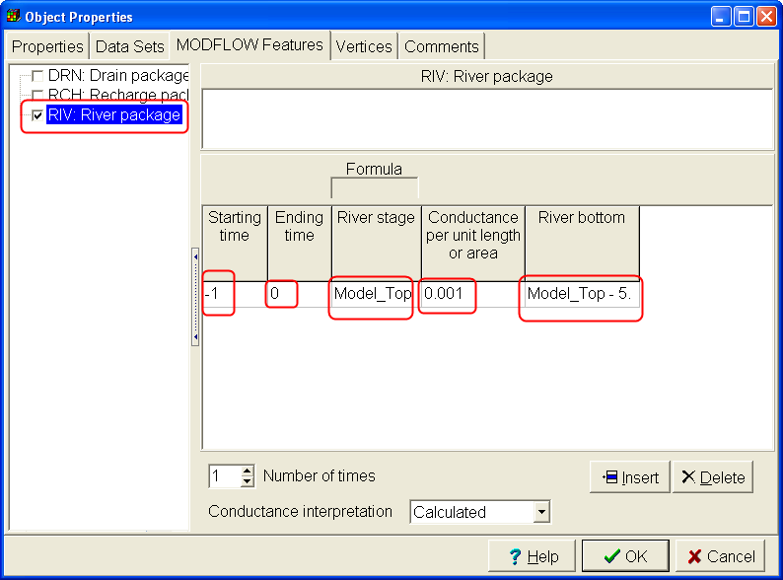
- Head observations are frequently used to help calibrate a model. We will enter some head observations. First activate the Head Observation package. Select Model|MODFLOW Packages and Programs, expand Observations and check the check box for the Head Observation package.
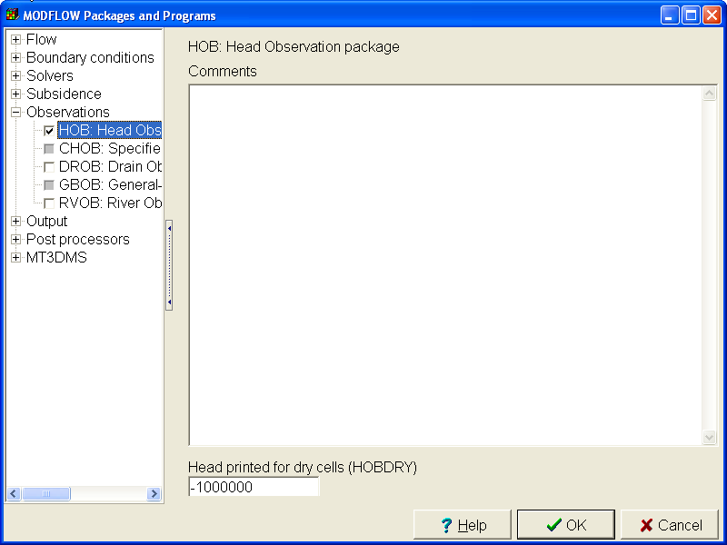
- Use point objects to define the locations of the head observations. You can put them wherever you think they will be most useful. The formula or formulas for the Z-coordinates define the layer or layers on which the observation is located. On the MODFLOW Features tab, select the check box for the Head Observation package. Enter values for the observation name, time, observed head, statistic and StatFlag. Because this is a steady-state model and the final time is zero. You must enter zero for the observation time. If this were a transient model, you could enter any time. We won’t be calibrating the model so you can put in anything for the observed head, statistic and StatFlag. If you wanted to explicitly specify the layers for the observation, you could do that on the Layers tab.
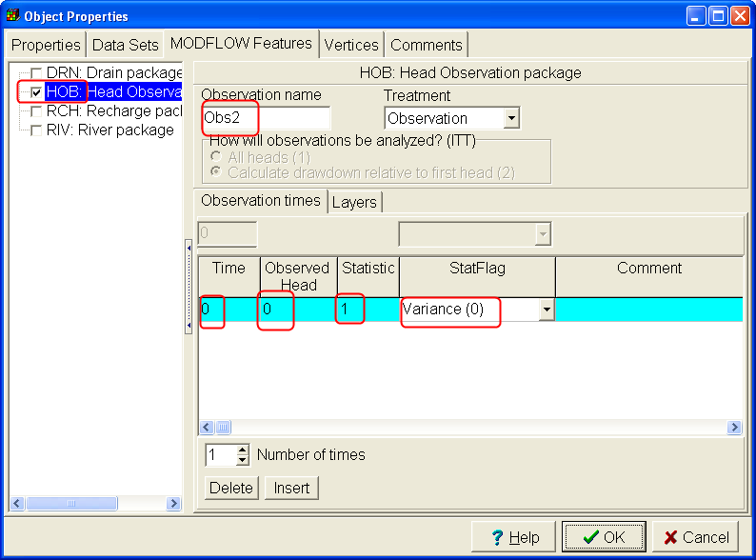
- Now we are ready to save and then run the model. Select File|Save and set the file name to Watershed. Then select “File|Export|MODFLOW input files” and click Save. ModelMonitor will open and run MODFLOW. ModelMonitor will display any error or warning messages generated by MODFLOW. It also plots the percent discrepancy in the water budget. If the percent discrepancy is too large (> 1%) the model is not sufficiently accurate. (However a percent discrepancy less than 1% does not guarantee that the model is good enough.
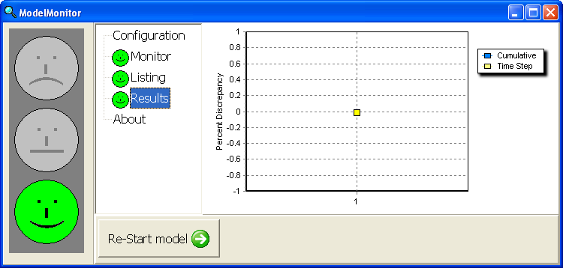
- Close ModelMonitor and the MODFLOW Listing file will open. Go to the end of the listing file and write down the amount of flow out of the model for the river and drain. Also write down the simulated heads for your head observations.
- Select File|Import Model Results and open Watershed.fhd. Color or contour the grid with the simulated heads.
- Now save the ModelMuse file again but call it Watershed2. Then try doubling both the recharge rate and the hydraulic conductivity. Run the model and compare the amount of flow out of the model for the river and drain with your previous results. Are they different? Could this difference be significant for how the groundwater is managed? Compare the observed heads for this model with your previous results. Would you be able to distinguish this model from the previous one based only on the observed heads?
- (Optional) Try starting another copy of ModelMuse and import the model you created.
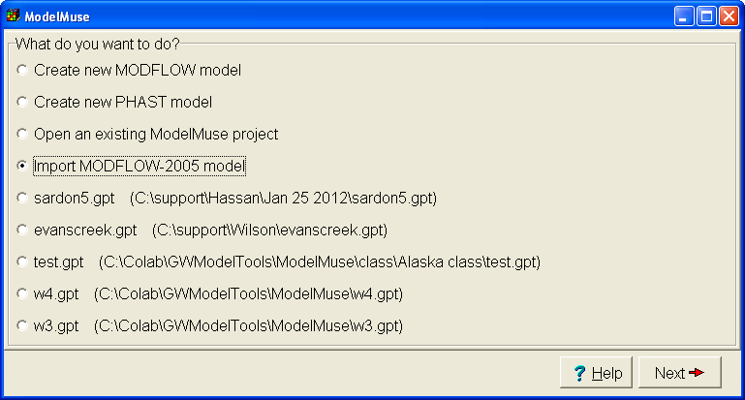
- Now select “Object|Show or Hide Objects” and check the check box for the river package. Compare the appearance of the object that defines the river in the imported model with the original model. How are they different?
